This zipped file includes:

Manual Temperature and Pressure Data.xlsx – This file shows the field calibration of the downstream temperature and pressure gages.

Field Calibration of Flow Meters.xlsx – This file shows the field calibration of the downstream flow meters and the corrections that were applied to the Pason data. NOTE – only raw Pason data are reported.

Extended Circulation Test Data 08082024 to 09052024 (30 sec increment).xlsx – RAW, UNCORRECTED digital data

Column A: Date & Time (Mountain Time).
Column B: The pressure measured at the wellhead for well 16B(78)-32 (psig).
Column C: Uncorrected discharge flow rate at Well 16B(78)-32, upstream of the separator (gpm).
Column D: The uncorrected discharge flow rate for a second, redundant flow meter at Well 16B(78)-32, upstream of the separator (gpm).
Column E: Uncorrected temperature at Well 16B(78)-32, upstream of separator (°F).
Column F: Uncorrected discharge rate through the first of two lines leaving the separator downstream of the 16B(78)-32 wellhead, flowing into the sump (gpm).
Column G: Uncorrected discharge rate through the second of two lines leaving the separator downstream of the 16B(78)-32 wellhead, flowing into the sump (gpm).
Column H: The uncorrected flow rate leaving the separator. It is the sum of Columns F and G (gpm).
Column I: The wellhead pressure at well 16A(78)-32 as measured by a transducer at the wellhead (psig).
Column J: The volumetric flow rate into well 16A(78)-32, as measured by Liberty Oilfield Services.
Column K: The wellhead pressure at well 16A(78)-32 as measured by Liberty Oilfield Services (psig).

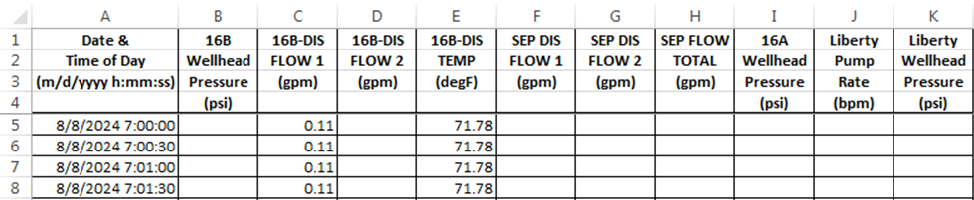

Extended Circulation Test Report-Final.docx – This document describes the extended circulation test and shows how the Pason data can be corrected for calibrations that were done in the field. A plot of efficiency (ratio of mass flow rates) is provided.

